Практическая работа №1

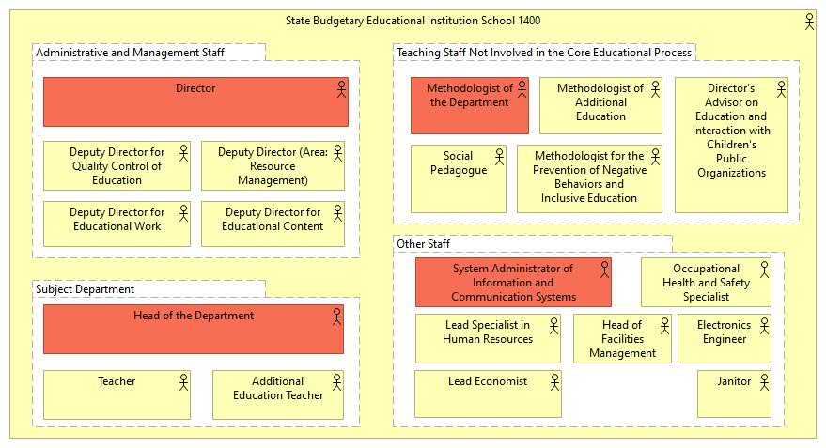

1. Director

- The Director is responsible for the overall management of the school, including decision-making, setting educational goals, and overseeing staff and resources.

2. Deputy Director for Quality Control of Education

- The Deputy Director for Quality Control of Education ensures that the educational processes meet the required standards and implements improvements to enhance teaching quality.

3. Deputy Director (Area: Resource Management)

- The Deputy Director for Resource Management is responsible for overseeing the school’s resources, including budgeting, facilities, and staff allocation.

4. Deputy Director for Educational Work

- The Deputy Director for Educational Work coordinates educational activities, develops curricula, and supervises extracurricular programs to support students' development.

5. Deputy Director for Educational Content

- The Deputy Director for Educational Content is responsible for developing and implementing the school’s curriculum, ensuring that the educational content aligns with academic standards and the needs of the students.

6. Head of the Department

- The Head of the Department leads the subject department, supervises teachers, and ensures the quality of education in their specific subject area.

7. Teacher

- The Teacher is responsible for delivering lessons, assessing student progress, and creating a positive learning environment in the classroom.

8. Additional Education Teacher

- The Additional Education Teacher provides supplementary educational programs, such as extracurricular activities and special interest groups, to enhance students' skills and knowledge.

9. Methodologist of the Department

- The Methodologist of the Department develops teaching methods, supports teachers in their professional growth, and ensures effective teaching practices.

10. Methodologist of Additional Education

- The Methodologist of Additional Education develops and improves programs related to extracurricular activities, helping teachers implement them effectively.

11. Director's Advisor on Education and Interaction with Children's Public Organizations

- The Director’s Advisor on Education and Interaction with Children’s Public Organizations advises on student engagement and works with external youth organizations to promote student development.

12. Social Pedagogue

- The Social Pedagogue supports students' social development, helps with personal issues, and promotes a positive school environment.

13. Methodologist for the Prevention of Negative Behaviors and Inclusive Education

- The Methodologist for the Prevention of Negative Behaviors and Inclusive Education develops and implements programs aimed at preventing behavioral issues and promoting inclusivity.

14. System Administrator of Information and Communication Systems

- The System Administrator manages the school's IT infrastructure, ensures the functionality of communication systems, and provides technical support for staff and students.

15. Lead Specialist in Human Resources

- The Lead HR Specialist oversees recruitment, employee relations, and other human resources functions to ensure the smooth operation of the school.

16. Lead Economist

- The Lead Economist is responsible for financial planning, budgeting, and managing the school’s financial resources.

17. Head of Facilities Management

- The Head of Facilities Management ensures the proper maintenance and operation of the school’s physical infrastructure, including buildings and equipment.

18. Electronics Engineer

- The Electronics Engineer manages the school’s electronic systems, ensuring their proper functioning and maintenance.

19. Occupational Health and Safety Specialist

- The Occupational Health and Safety Specialist ensures that the school complies with safety regulations and that the working environment is safe for staff and students.

20. Janitor

- The Janitor is responsible for maintaining cleanliness and orderliness within the school premises.